1. Overview
1.1 Project Objectives and System Architecture
The primary objective of this project is to develop a comprehensive, high-interaction web application that addresses the "last-mile" transportation challenges in Dublin by integrating real-time data, meteorological information, and predictive analytics. The system provides users with live occupancy status for Dublin Bikes stations while leveraging machine learning to assist in travel decision-making under Dublin's unpredictable weather patterns.
Architecturally, the project utilizes a decoupled client-server and cloud architecture, strictly separating front-end user interfaces, back-end web routing, and data acquisition processes. The work is split across three independent Git repositories, each with a dedicated CI/CD pipeline:
- flask-app: The REST API backend managing authentication, station availability, ML predictions, and AI chat logic.
- react-app: A TypeScript-based single-page application (SPA) providing a dynamic and responsive user experience.
- scraper: A standalone data ingestion engine for JCDecaux and OpenWeather APIs.
The system is containerized via Docker and deployed on AWS EC2, utilizing AWS RDS (MySQL) for centralized, high-performance data persistence, ensuring that long-running ingestion tasks do not block API responses.
1.2 Target Users and Personas
Based on the requirements elicitation process in Sprint 1, we identified three core personas to guide our feature development:
- Eoin (The Daily Student Commuter): A budget-conscious student relying on cycling for his 9:00 AM lectures. His primary pain points are finding empty stations and getting caught in rain.
  - Solution: Integrated weather forecasts and a 24-hour bike availability prediction model.
- Sarah (The Punctual Office Worker): A professional commuting to the Silicon Docks who requires maximum efficiency and route certainty.
  - Solution: The Journey Planner feature, which calculates the optimal "walk-cycle-walk" route to minimize total travel time.
- Matteo (The Weekend Tourist): A visitor unfamiliar with the city layout who needs an intuitive interface to find stations near landmarks.
  - Solution: High-interaction map visualization and a Generative AI Chatbot for natural language assistance.
1.3 Core Functional Features
A. Interactive Map Visualization & Weather Integration
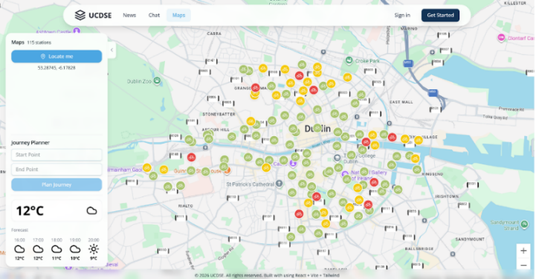
Figure 1.1: Main interactive dashboard with dynamic station status and real-time weather integration.
Built with React and the Google Maps SDK, the interactive dashboard provides a real-time visual representation of the Dublin Bikes network alongside an integrated weather forecasting utility. A dynamic color-coding mechanism (green, yellow, red) enables rapid assessment of station availability, while station click events trigger asynchronous API requests to fetch detailed occupancy history. To assist with travel decisions, the frontend consumes meteorological data—fetched hourly from the OpenWeatherMap API by a background scraper and persisted in AWS RDS—displaying live conditions and upcoming forecasts seamlessly within the same interface.
B. Comprehensive Station Dashboard & Predictive Analytics
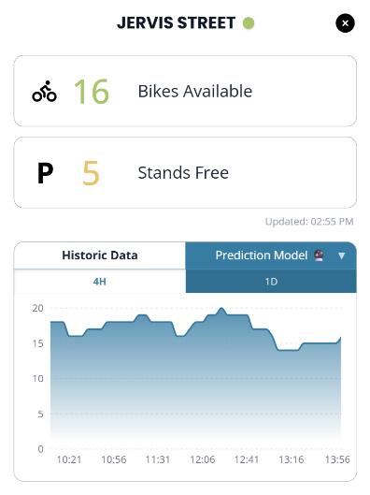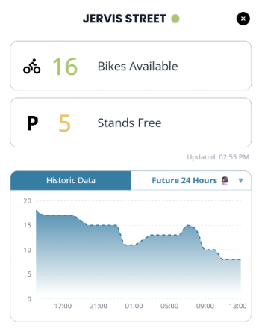
Figure 1.2: ML-driven 24-hour bike availability forecast for a selected station.
Upon clicking a station marker, users are presented with a detailed, interactive pop-up window. This dashboard provides an immediate snapshot of the station's real-time status, clearly displaying the exact number of available bikes and free stands. Beyond live metrics, the interface features a dynamic, dual-tabbed chart component. Users can seamlessly toggle between "Historic Data" to analyze recent occupancy trends and the "Prediction Model" to view a 24-hour machine learning-driven forecast.
1.4 Advanced Optional Features
A. Global Minimum Duration Journey Planner
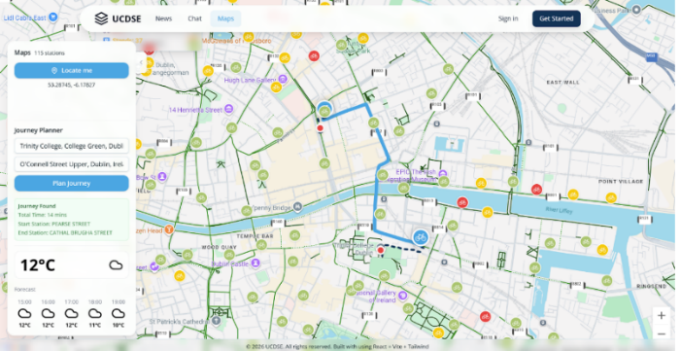
Figure 1.3: Journey Planner demonstrating the globally optimized "walk-cycle-walk" routing.
The Journey Planner utilizes a Global Minimum Duration Algorithm to recommend the most time-efficient route for users. By analyzing real-time station availability alongside multi-modal travel data from Google Maps, the system dynamically identifies the fastest "walk-cycle-walk" combination to minimize the overall commute time. This ensures that users are guided to operative stations with confirmed bike or stand availability, providing a reliable and optimized travel experience.
B. Secure Authentication and Session Management
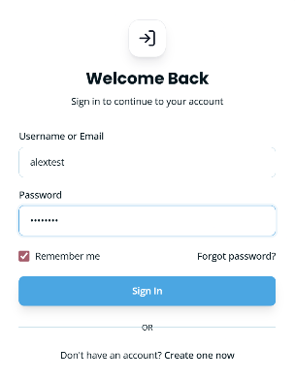
Figure 1.4: Secure JWT-based authentication and account activation interface.
The system features an enterprise-grade security layer utilizing JWT (Access/Refresh Tokens) and 6-digit email verification. Authentication states are isolated in the user and sessions tables of the AWS RDS instance, ensuring secure access to personal chat histories and profile settings.
C. Stateful Generative AI Support
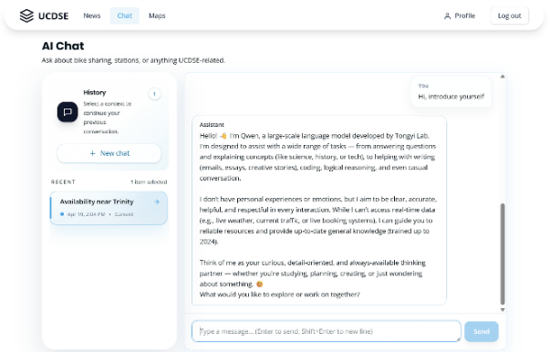
Figure 1.5: LLM-powered assistant with session persistence and natural language processing.
Leveraging the LangChain framework and Aliyun Qwen API, we developed a stateful AI assistant. The backend utilizes native JSON columns in the message_store table to archive complex chat interactions, allowing the model to maintain context across sessions and automatically classify chat topics.
2. Requirements
2.1 Requirements Elicitation Process
To ensure the Dublin Bikes application delivers meaningful value to its diverse user base, we implemented a structured, user-centric requirements elicitation process during Sprint 1. The goal was to bridge the gap between high-level project objectives and concrete technical specifications through empirical research and stakeholder analysis.
The process followed four distinct phases:
- Market Research & Competitive Analysis: We conducted a benchmarking study against existing bike-sharing platforms such as the official TFI Bikes app, Villo! (Brussels), and Santander Cycles (London). This research identified a significant market gap in Dublin: the lack of integrated predictive availability and real-time weather-sensitive routing.
- Qualitative User Interviews: To understand local pain points, we conducted structured interviews with three primary stakeholders. These sessions focused on daily commuting habits, the impact of Dublin’s unpredictable weather, and the frustrations associated with "station-full" or "station-empty" scenarios.
- Persona Synthesis: Insights from the interviews were synthesized into three distinct personas: Eoin (the budget-conscious student), Sarah (the punctual professional), and Matteo (the weekend tourist). These personas served as the "living documentation" that guided every design decision.
- User Story Mapping: Finally, we translated user needs into formal User Stories and Acceptance Criteria (AC). This provided us with a clear "Definition of Done" for each feature and formed the basis of our automated testing suite.
2.2 App Mockups and Design Rationale
The following mockups represent the most critical interfaces of the application, designed to address the specific needs identified during the elicitation process.
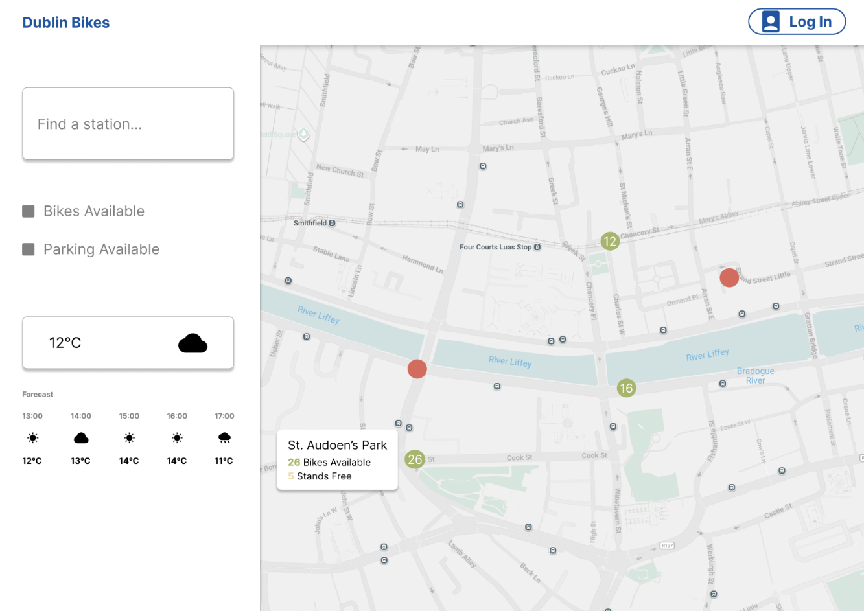
Figure 2.1: Primary dashboard featuring the Google Maps SDK integration and weather widget.
Design Focus: This interface establishes foundational situational awareness for the user. By utilizing a clean, full-screen map layout paired with interactive hover states. Additionally, the integrated sidebar features a streamlined search function for rapid spatial navigation, alongside a real-time weather widget that facilitates immediate "go/no-go" travel decisions.
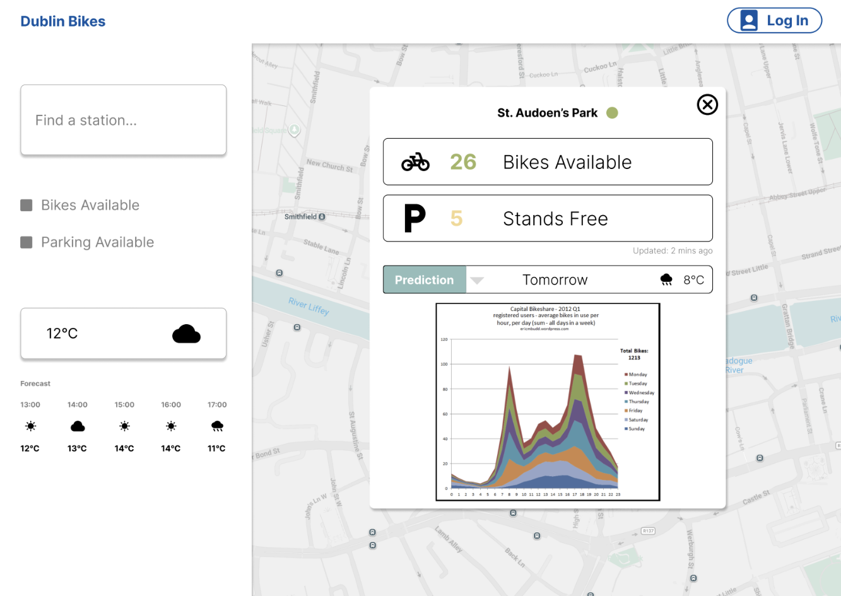
Figure 2.2: Detailed station view showing the toggle between Historical Trends and ML Predictions.
Design Focus: To alleviate Sarah’s anxiety regarding morning meetings, this dashboard provides predictive certainty. By clicking a station, users can view a 24-hour forecast powered by our Random Forest model, allowing for preemptive planning of commutes based on projected availability rather than just live snapshots.
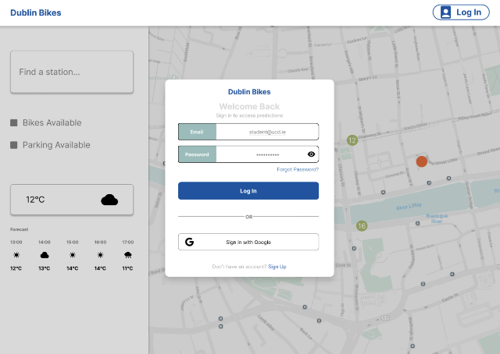
Figure 2.3: User login interface.
Design Focus: This interface provides a secure and straightforward user authentication process. By facilitating simple registration and login workflows, it ensures that users can safely manage their personal accounts and access customized features, such as their saved AI chat history.
2.3 User Stories and Acceptance Criteria
The following table outlines the core functional requirements that drove the development of the Dublin Bikes ML App.
User Story ID | User Story Description | Acceptance Criteria (AC)
US-01 | As a student running late (Eoin), I want to see real-time bike counts on the map, so that I don't waste time walking to an empty station. | 1. Markers must update dynamically via JCDecaux API.  2. Clicking a marker must display the exact count of bikes/stands.
US-02 | As a commuter planning ahead (Sarah), I want to view predicted availability for the next 24 hours, so that I can plan my morning journey. | 1. The "Prediction Model" tab must render an ML-driven chart.  2. Predicted values must be mathematically clamped between 0 and station capacity.
US-03 | As a time-sensitive professional (Sarah), I want to use a journey planner to find the fastest route, so that I arrive at my meetings efficiently. | 1. System must calculate the optimal Walk-Cycle-Walk combination.  2. The map must render a polyline route with an associated ETA.
US-04 | As a tourist (Matteo), I want to ask questions using natural language via an AI assistant, so that I can understand rental rules easily. | 1. The GenAI Chatbot must process queries using LangChain/LLM.  2. Conversation history must be persisted for authenticated users.
US-05 | As a frequent user, I want to register and log in securely, so that I can access personalized features like saved routes and AI chat. | 1. Registration must require a 6-digit email verification code.  2. The system must issue and validate secure JWT tokens.
2.4 Supplementary Material
To maintain a concise report, the extensive raw data generated during the requirements phase has been archived. This includes:
- Full Interview Transcripts: Comprehensive logs from sessions with Sarah, Matteo, and Eoin.
- Detailed Persona Profiles: In-depth analysis of user demographics, goals, and frustrations.
- Competitive Analysis Matrix: A technical feature comparison across major European bike-sharing systems.
Reference Note: All aforementioned comprehensive documentation related to our elicitation process can be accessed in our GitHub repository at: https://github.com/ucdse/docs/tree/main/requirements

